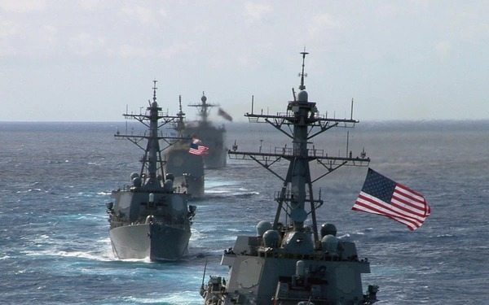***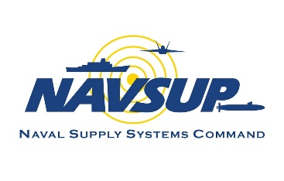****Supply Corps Team,*****

**OP Monthly**

**November 2023**

**In this month’s edition of the OP Monthly, we highlight the Logistics Information Technology Management competency. This competency is critical to the Supply Corps’ development and implementation of strategies that touch everything from everyday shipboard programs to warfighter sustainment in contested environments.**

**We also touch on the importance of records management, discuss the differences in reserve component designations, feature the Executive Development Program, and introduce a new OP Team member. At the end of this edition, we have again listed the dates for our upcoming 2023-2024 Roadshow season. We look forward to seeing you soon and providing important community guidance.**

**Thank you for everything that you do!**



**CAPT Alsandro H. (Jay) Turner**

**Director, Supply Corps Personnel**

# New and Noteworthy…

## *Competency in the Spotlight: Logistics Information Technology Management*

**Overview**

Information technology continues to transform the way the Navy conducts business and warfare. Supply Chain Management and Logistics are rapidly becoming dependent on ever evolving technologies and information systems. Logistics Information Technology Management (LOG IT) officers are responsible for the acquisition, management, and infrastructure of afloat and ashore IT solutions. Officers play a critical role in the development and implementation of strategies and policies that take advantage of emerging technology, mitigate risk, and synchronize supply chains. Supply Corps officers in the LOG IT competency can expect assignments as program managers at commands with hardware and software related procurement responsibilities.

***Click to learn more about Logistics IT Management. . .***

Examples of LOG IT duties are identified below:

**NAVSUP BSC Project Officer:**

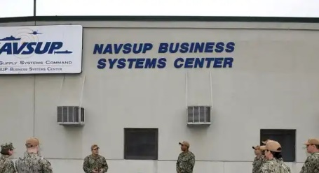Duties involve management of fleet support applications, such as Navy Enterprise Resource Planning (ERP), Food Service Management (FSM), Retail Operations Management (ROM), OneTouch Support (OTS), eRetrograde Management System (eRMS), Hazardous Inventory Control System (HICS), etc. Project officers oversee the execution of programmed budgets used to develop, sustain, and enhance critical fleet IT systems. Officers also gather requirements from stakeholders and mission partners used to develop technical solutions.

**Program Executive Office Manpower Logistics and Business (PEO MLB) Systems Assistant Program Manager (APM):**

Officers filling APM roles at PEO MLB are responsible for the cost, schedule, and performance of Navy-wide Enterprise LOG IT programs. APMs direct and oversee the development, testing, integration, and installation of systems critical to daily fleet operations. Supply Corps officers in these acquisition billets are responsible for aligning their programs with the requirements of Echelon II level stakeholders and are direct participants in the Planning, Programming, Budget, and Execution (PPBE) process.

**Defense Logistics Agency (DLA) Headquarters J6 (J68 Research and Development) Project Officer:**

Supply Corps officers at DLA’s Research and Development (J68) office can expect to create and deliver new capabilities through applied technologies and innovative solutions to enhance warfighter sustainment. Project officers work with industry leaders, academia, and federal stakeholders to support the warfighter, whether in a contested logistics environment or in forward operations. Officers serve as project managers to build short- and long-term plans for effective technical, financial, and program execution of assigned R&D projects / programs.

**Becoming a LOG IT**

Becoming a LOG IT officer at the senior level requires several experience tours to learn all aspects of the competency. Supply Corps officers can begin their journey as junior officers, gaining valuable experience and insight into the IT management community. Supply Corps LOG IT managers gain a Life Cycle Logistics Defense Acquisition Workforce Improvement Act (DAWIA) certification. Additionally, officers may gain a Master’s Degree in LOG IT from the Naval Postgraduate School.

Example LOG IT Billets:

* CAPT: NAVSUP BSC Commanding Officer, OPNAV N4L, NAVSUP HQ, and DLA HQ
* CDR: NAVSUP BSC, PEO MLB, ASN FMC, DISA, and DLA HQ
* LCDR: NAVSUP BSC, COMUSFLTCYBCOM, PEO MLB, and DLA HQ
* LT/LTJG: NAVSUP BSC or Business Enterprise Management (BEM) Internships at NAVSUP BSC, NAVSUP WSS MECH, NAVSUP WSS PHIL, and NAVAIR

For more information about LOG IT, reach out to CDR Brian Bieber, NAVSUP HQ - SUP 0452, at [brian.m.bieber.mil@us.navy.mil](mailto:brian.m.bieber.mil@us.navy.mil).

***Meet the… Assistant to the Director, Detailing / Assistant Commander Detailer (P1A)***

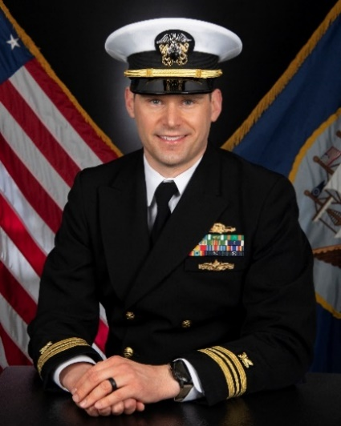Lieutenant Commander Kevin Matthew Wall is a native of Midwest City, Oklahoma. He graduated from the University of Oklahoma in 2007 with a Bachelor of Arts in Journalism. He was commissioned in 2009 through Officer Candidate School and subsequently graduated from Navy Supply Corps School in Athens, Georgia. In 2014, he earned his Master of Business Administration from The Citadel in Charleston, South Carolina. In addition, in 2016, he completed the Navy Understanding Industry Executive Education program from the University of Virginia Darden School of Business and the Joint Professional Military Education (JPME) Phase I program from the U.S. Naval War College.

***Click to read more about LCDR Wall. . .***

Operationally, LCDR Wall served as Assistant Supply Officer onboard USS SAMUEL B. ROBERTS (FFG 58), Mayport, Florida, where the Supply Department earned two consecutive Blue “E” Logistics Management Excellence Awards (2010 and 2011). He deployed to the Mediterranean Sea, West Africa, and East Africa in support of Africa Partnership Station and 5th Fleet anti-piracy operations. His second tour was assigned to Naval Special Warfare Group Logistics and Support Unit TWO (LOGSU 2), Little Creek, Virginia, where he served as N4/Logistics Officer (Combat Service Support Troop Commander) for SEAL Team FOUR. He deployed with SEAL Team FOUR as the Special Operations Command Forward– East Africa (SOCFWD-EA) J4 Director to Djibouti / Somalia in support of Operation Enduring Freedom – Horn of Africa. His third operational tour was served onboard USS NIMITZ (CVN 68), Bremerton, Washington, as Assistant Supply Officer where the Supply Department earned two consecutive Blue “E” Awards (2021 and 2022). He also served as Principal Assistant for Services and the Food Service Officer. He deployed to 7th Fleet in support of operations in the United States Indo-Pacific Command (USINDOPACOM) area of responsibility.

Ashore, he served as Supply Officer of Naval Consolidated Brig Charleston, Charleston, South Carolina; Navy Acquisition Contracting Officer (NACO) intern at Naval Information Warfare Systems Command (NAVWAR), San Diego, California; and as a Contracting Officer at Office of Special Projects (OSP) West Coast Detachment, San Diego, California. He is currently serving as the Assistant to the Director, Supply Corps Detailing / CDR Detailer (OP1A) at Office of Supply Corps Personnel (PERS-4412), Navy Personnel Command, Millington, Tennessee.

His personal decorations include the Joint Service Commendation Medal, Navy and Marine Corps Commendation Medal (four awards), Navy and Marine Corps Achievement Medal, and various campaign and unit awards. LCDR Wall is a qualified Naval Aviation Supply Officer, Naval Expeditionary Supply Corps Officer, Surface Warfare Supply Corps Officer, Acquisition Professional Member, and Contracting Professional (DAWIA Level III in Contracting). He is a recipient of the 2018 Navy League of the United States Vice Admiral Robert F. Batchelder Award for his service as Logistics Officer for SEAL Team FOUR and SOCFWD-EA.

***From the AC Career Counselor’s Desk***

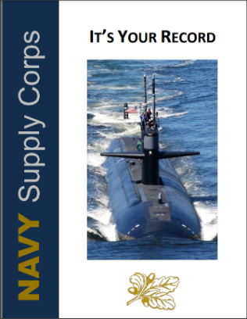Are you keeping your record up-to-date? Regular audits of your record are critical to ensure your Naval career is accurately represented. Mentors, the [It’s Your Record](https://mynavyhr.navy.afpims.mil/Portals/55/Career/Detailing/Officer/StaffCorps/Supply/It's%20Your%20Record%20v.2.pdf?ver=n0mVwkzyReq4GN4wCVwZDQ%3d%3d) playbook, and community updates are valuable resources to help ensure your record is board-ready.

Should you desire further assistance, the Active Component and Reserve Component Career Counselors are able to provide thorough, individual record reviews.

***Click to read more about what is encompassed in a Record Review. . .***

A standard record review with the Supply Corps Career Counselors takes approximately 30-45 minutes and will cover, but is not limited to:

* Candid review of your Performance Summary Report (PSR), Officer Data Card (ODC), and Officer Summary Report (OSR)
  + Periodic Gaps / Date Overlaps
  + Individual Trait Average (ITA) to Summary Group Average (SGA) and Reporting Senior Cumulative Average (RSCA) analysis
  + Promotion Recommendation and Air Gaps
* ODC / OSR
  + Subspecialties (SUBSPECs)
  + Education and Service Schools
  + Awards
  + Additional Qualification Designation (AQD) Codes
  + Navy Officer Billet Classification (NOBC) Codes
* Record update recommendations
* Comparison of your career progression to Community Values
* Review of key documents and their utility for both career planning and FITREP writing
  + SECNAV Precepts and Board Convening Order
  + Community Values and Career Progression Chart
  + Merit Reorder Brief

The Supply Corps Career Counselors, CDR Long Tran and LCDR Bethany Satterwhite, can be reached at [supply_corps_cc@navy.mil](mailto:usn.mid-south.navsuphqmech.mbx.supply-corps-cc@us.navy.mil) to schedule a records review by phone or Microsoft Teams.

***From the RC Career Counselor’s Desk***

The Navy Reserve has a long, proud history of providing strategic depth and operational capability to the Navy and Marine Corps team and joint forces. The Navy Reserve is a force of highly trained personnel, trained to meet the expanded needs of the Navy. The reserve component of the Supply Corps is comprised of the 3105 Selected Reservist (SELRES) and 3107 Training and Administration of Reserve (TAR) designations.

***Click to read more about the difference between the 3105 and 3107 Communities. . .***

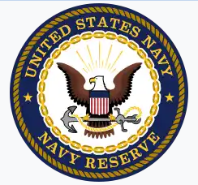The 3105 SELRES community is an integral part of supporting the mission and its warfighting efforts. Our SELRES team is comprised of approximately 800 members, and is uniquely positioned to offer warfighting capabilities to the active duty component across a wide spectrum of efforts via acquisition-contracting, supply chain management, expeditionary logistics, and operational planning. Along with being dedicated warfighters, the SELRES team brings skillsets and experience from their civilian careers, integrating best practices from a variety of civilian industries into the Navy Supply Corps.

Our 3107 TAR Officers are a selective, dedicated force of Supply Corps officers whose mission is to conduct training and administration of SELRES. They provide cohesive integration between the Active and Reserve Supply Corps Communities, helping bridge the gap between both communities.

If you would like to know more about the reserve Supply Corps communities, and how they contribute to the Navy mission, reach out to LCDR Bethany Satterwhite or CDR Treven Feleciano, the new TAR detailer.

***Executive Development Program***

The Supply Corps Executive Development Program (EDP) provides senior Supply Corps officers with a short-term training program focused on enhancing leadership skills, innovative and creative thinking, and strategic decision-making capabilities. EDP leverages post-graduate level civilian institutions to provide eligible officers with exposure to corporate executives and innovative strategies used in today’s dynamic business environments. The program is viewed as a strategic investment in our senior officer corps, with anticipated strategic thinking, decision-making, and leadership returns on investment.

***Click to learn more about the EDP eligibility requirements and signing up for the course. . .***

Per NAVSUPINST 1520.6C, available for download via the [Naval Logistics Library](https://my.navsup.navy.mil/apps/ops$nll.view_publication_details?P_PUBLICATION_ID=81538), officers must meet the following criteria to be considered:

* Captains with less than three years time in grade, or a Captain-select
* 3100 or 3107 designated officer
* Completed Joint Professional Military Education (JPME) Phase I
* Have not previously attended a NAVSUP-funded executive development or executive training program

Note: officers who do not meet eligibility requirements may submit a written request for exception. Participants are required to agree in writing to a 2-year service obligation for participating in the program, which will commence upon completion of the EDP course.

The FY 24 EDP season began October 1, 2023 and a list of available courses has been released to eligible officers. Interested officers should submit preferences to Mr. Nicholas Alvarez as soon as possible. Selection for courses is based on seniority for the first month, then changing to a first-come, first-served basis. If you believe that you are eligible and did not receive an email invitation, please reach out to Mr. Alvarez at your earliest convenience.

For questions regarding the Executive Development Program, please contact Mr. Nicholas Alvarez at nicholas.e.alvarez.civ@us.navy.mil or the Supply Corps Career Counselor.

***2023 – 2024 OP Roadshow***

NAVSUP OP is hitting the road and heading your way! The OP Team will present valuable career information, discuss different facets of the Supply Corps community, and conduct one-on-one career interviews.

Be sure to update contact information with the local Navy Supply Corps Foundation (NSCF) chapter in order to receive the latest and greatest information. For NSCF chairs, feel free to reach out to the Supply Corps Career Counselor team for assistance with ensuring all member’s information is up-to-date.

***Click to see the 2023 – 2024 OP Roadshow dates. . .***

11 – 15 December DLA Land & Maritime / USTRANSCOM

8 – 12 January Mechanicsburg / Philadelphia

22 – 26 January Washington, DC / Patuxent River

5 – 9 February San Diego

4 – 8 March Pacific Northwest / Naval Postgraduate School

18 – 22 March Norfolk / Little Creek

1 – 5 April Jacksonville / MacDill AFB

18 – 20 April Fort Worth (Reserve Component)

15 – 24 April Pearl Harbor / Guam

11 – 14 May Reserve Component Virtual

20 – 24 May Bahrain

3 – 7 June Groton / New England

10 – 11 June CONUS Virtual

12 June 6th Fleet Virtual

13 – 15 June 7th Fleet Virtual

*Schedule is subject to change.

# Important Links

[**FY 25 Board Schedule**](https://www.mynavyhr.navy.mil/Portals/55/Boards/Selection/FY25%20WEB.pdf?ver=zbZqXBvSeXTV2rGEdgGGfg%3d%3d)

[**FY 24 Active Duty Promotion Selection Board Zone Message (NAVADMIN 270/22)**](https://www.mynavyhr.navy.mil/Portals/55/Messages/NAVADMIN/NAV2022/NAV22270.txt?ver=eyBAkY5YMAmlnEr6F_IYLQ%3d%3d)

[**FY 24 Reserve Promotion Selection Board Zone Message (NAVADMIN 292/22)**](https://www.mynavyhr.navy.mil/Portals/55/Messages/NAVADMIN/NAV2022/NAV22292.txt?ver=yDvanRuorMx6hmtFdLxa9w%3d%3d)

## *Contact Us*

|  |  |  |
| --- | --- | --- |
| **Position** | **Name** | **E-mail** |
| Director | CAPT Jay Turner | alsandro.h.turner2.mil@us.navy.mil |
| Director, Detailing Division | CAPT Dena Risley | dena.b.risley.mil@us.navy.mil |
| OP Assistant | CDR Travis Miller | travis.m.miller24.mil@us.navy.mil |
| OP1 Assistant | LCDR K. Matt Wall | kevin.m.wall10.mil@us.navy.mil |
| Reserve & TAR Director | CAPT Dave Davis | david.w.davis10.mil@us.navy.mil |
| TAR Mgt. Branch Detailer | CDR Treven Feleciano | treven.s.feleciano.mil@us.navy.mil |
| “Pit Boss” / LCDR Detailer | CDR Dustin Martindale | dustin.r.martindale.mil@us.navy.mil |
| LT Operational / PG School | LCDR Winston Lamb | winston.c.lamb.mil@us.navy.mil |
| LT Shore Detailer | LCDR Nicholas Mays | nicholas.c.mays.mil@us.navy.mil |
| CWO / BQC / Submarine Detailer | CWO5 Benny Brockington | benny.brockington.mil@us.navy.mil |
| AC Career Counselor | CDR Long Tran | long.k.tran.mil@us.navy.mil |
| RC Career Counselor | LCDR Bethany Satterwhite | bethany.c.satterwhite.mil@us.navy.mil |
| Accessions / Internship Officer | LT Lydia Sankey | lydia.j.sankey.mil@us.navy.mil |
| Director, Supply OCM | CDR Leanne Riley | leanne.r.riley.mil@us.navy.mil |
| Deputy, Supply OCM | Ms. Beth Schudel | beth.r.schudel.civ@us.navy.mil |
| Director, Reserve OCM | CDR Eric Gardner | eric.a.gardner5.mil@us.navy.mil |
| Supply Corps Career Counselor Inbox: [usn.mid-south.navsuphqmech.mbx.supply-corps-cc@us.navy.mil](mailto:usn.mid-south.navsuphqmech.mbx.supply-corps-cc@us.navy.mil) | | | |

# *Supply Corps Officer Strength*

**3100 Active Component**

|  |  |  |  |  |  |  |  |  |  |  |
| --- | --- | --- | --- | --- | --- | --- | --- | --- | --- | --- |
| **Paygrade** | **Authorized** | | **Inventory** | | **Gross Over/Under** | | **Non-Distributable Inventory** | | **Total Delta** | |
| **O-6** | | 172 | | 166 | | **-6** | | 6 | | **-12** | |
| **O-5** | | 353 | | 334 | | **-19** | | 5 | | **-24** | |
| **O-4** | | 533 | | 485 | | **-48** | | 2 | | **-50** | |
| **O-3** | | 712 | | 612 | | **-100** | | 13 | | **-113** | |
| **O-2** | | 267 | | 304 | | **37** | | 17 | | **20** | |
| **O-1** | | 258 | | 273 | | **15** | | 5 | | **10** | |
| **Totals** | | **2295** | | **2174** | | **-121** | | **48** | | **-169** | |

Data source: the Officer Inventory / Authorization (Tri-Color) dated 31 October 2023.

Note: Officers selected for promotion in FY23 are listed in their current rank. Officers are detailed to billets in the next higher rank, resulting in lower distributable LT inventory numbers.

**3107 Reserve Component –Training and Administration of the Reserves (TAR)**

|  |  |  |  |
| --- | --- | --- | --- |
| **Paygrade** | **Authorized** | **Inventory** | **Delta** |
| **O-6** | 8 | 10 | **2** |
| **O-5** | 26 | 23 | **-3** |
| **O-4** | 32 | 39 | **7** |
| **O-3** | 26 | 19 | **-7** |
| **O-2** | 0 | 4 | **4** |
| **O-1** | 1 | 1 | **0** |
| **Totals** | **93** | **96** | **3** |

**3105 Reserve Component (RC) – Selected Reserves (SELRES)**

|  |  |  |  |
| --- | --- | --- | --- |
| **Paygrade** | **Authorized** | **Inventory** | **Delta** |
| **O-6** | 52 | 51 | **-1** |
| **O-5** | 171 | 170 | **-1** |
| **O-4** | 312 | 293 | **-19** |
| **O-3** | 195 | 146 | **-49** |
| **O-2** | 84 | 37 | **-47** |
| **O-1** | 25 | 72 | **47** |
| **Totals** | **839** | **769** | **-70** |

**3165 RC In-Training**

|  |  |  |
| --- | --- | --- |
| **Paygrade** | **Authorized** | **Inventory** |
| **O-3** | 0 | **0** |
| **O-2** | 0 | **4** |
| **O-1** | 0 | **68** |
| **Totals** | **0** | **72** |

**6510 Limited Duty Officer (LDO)**

|  |  |  |  |  |  |
| --- | --- | --- | --- | --- | --- |
| **Paygrade** | **Authorized** | **Inventory** | **Gross Over/Under** | **Non-Distributable Inventory** | **Total Delta** |
| **O-6** | 0 | 0 | 0 | 0 | **0** |
| **O-5** | 0 | 0 | 0 | 0 | **0** |
| **O-4** | 1 | 0 | **-1** | 0 | **-1** |
| **O-3** | 34 | 14 | **-20** | 1 | **-21** |
| **O-2** | 9 | 15 | 6 | 0 | **6** |
| **O-1** | 15 | 15 | 0 | 0 | **0** |
| **Totals** | **59** | **44** | **-15** | **1** | **-16** |

**7520 Food Service Warrant**

|  |  |  |  |  |  |
| --- | --- | --- | --- | --- | --- |
| **Paygrade** | **Authorized** | **Inventory** | **Gross Over/Under** | **Non-Distributable Inventory** | **Total Delta** |
| **CWO-5** | 3 | 6 | 3 | 2 | 1 |
| **CWO-4** | 10 | 9 | **-1** | 1 | **-2** |
| **CWO-3** | 25 | 26 | 1 | 4 | **-3** |
| **CWO-2** | 20 | 22 | 2 | 0 | 2 |
| Totals | 58 | 63 | 5 | 7 | **-2** |

# *Individual Augmentation (IA) Update*

Currently there are **49** filled Supply Corps IA requirements*:

Active Component (3100, 6510, 7520): **13**

|  |  |  |  |  |  |
| --- | --- | --- | --- | --- | --- |
| **Rank** | **Djibouti** | **Bahrain** | **Kuwait** | **Hawaii** | **Total** |
| ENS |  |  |  |  |  |
| LTJG | 2 |  |  |  | **2** |
| LT | 1 |  | 1 |  | **2** |
| LCDR | 5 | 1 | 1 | 1 | **8** |
| CDR |  |  | 1 |  | **1** |
| CAPT |  |  |  |  |  |
| **Total** | **8** | **1** | **3** | **1** | **13** |

Reserve Component (3165, 3105, 3107): **36**

|  |  |  |  |  |  |  |  |  |  |  |  |
| --- | --- | --- | --- | --- | --- | --- | --- | --- | --- | --- | --- |
| **Rank** | **Iraq** | **UAE** | **HOA** | **Bahrain** | **Kuwait** | **Germany** | **Korea** | **Hawaii** | **Guam** | **CONUS** | **Total** |
| ENS |  |  |  |  |  |  |  |  |  |  |  |
| LTJG |  |  | 3 |  |  |  |  |  | 1 |  | **4** |
| LT |  | 1 | 5 | 2 |  |  | 1 |  | 2 | 1 | **12** |
| LCDR | 2 |  | 2 | 5 | 1 | 5 |  |  |  | 1 | **16** |
| CDR |  |  | 1 |  | 1 |  |  | 1 | 1 |  | **4** |
| CAPT |  |  |  |  |  |  |  |  |  |  |  |
| **Total** | **2** | **1** | **11** | **7** | **2** | **5** | **1** | **1** | **4** | **2** | **36** |

*Data pulled 26 September 2023 from Individual Augmentation Portal represents count of Boots on Ground (BOG) at time of data pull.

NOTE: Mobilizations, IAs, and GSAs range from 6-12 months. Once assigned, GSA opportunities are updated and posted to [Supply Corps’ GSA Detailer page](https://www.mynavyhr.navy.mil/Career-Management/Detailing/Officer/Pers-44-Staff-RL/Supply-Corps-Officer/GSA-Detailer/) on MyNavy HR and the eSUPPO app via Billets > TAR/GSA function.